Task 1: Cat6 Cable T568B Wiring Diagram & Pinout

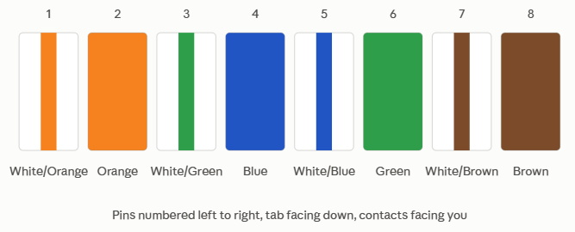
That's the T568B pin order — this is the standard used for most straight-through Ethernet cables today (a straight-through cable has the same order on both ends; a crossover cable uses T568A on one end and T568B on the other).

Task 2: Types of Network Cables & Real-World Use Cases

Cable | Real-World Use | Why
Cat5e | Wi-Fi Router to PC/modem, POS Terminal / Bill Printer | Point-of-sale machines only need to transmit small amounts of order text and credit card verification payloads. Good for a basic home Wi-Fi router-to-modem connection. It supports up to 1 Gbps, which is more than enough for typical home broadband speeds, and it's the cheapest option.
Cat6 | Gaming PC/ Console to Network Switch/ Wi-Fi 6 Router | It supports higher bandwidth (up to 10 Gbps up to 55 meters) with better shielding against interference, which matters in a busy commercial space with lots of electronics nearby, keeping order/payment data transfer fast and reliable for uninterrupted gaming and local streaming.
Fiber Optic | IPL Live Streaming Core Server / ISP Data Center Backbone | It carries far higher bandwidth over much longer distances without signal loss or electromagnetic interference — essential for handling massive concurrent video traffic during a live match.

Task 3: RJ-45 Crimping Process & Common Mistakes

Step-by-Step Crimping Process:
- Strip the Outer Jacket: Use a wire stripper or crimping tool blade to carefully cut and remove about 1.5 inches (3–4 cm) of the outer PVC jacket without scoring the copper wires underneath.
- Untwist and Align: Remove the internal plastic spline (if present on Cat6), untwist the four pairs down to the jacket edge, and straighten each wire out flat with your fingers.
- Arrange Colour Code (T568B): Line up the wires left-to-right: White-Orange, Orange, White-Green, Blue, White-Blue, Green, White-Brown, Brown.
- Trim Flush: Pinch the ordered wires firmly between your fingers and use wire cutters to make a straight, flat cut across all 8 conductors, leaving about 0.5 inches (1.25 cm) exposed.
- Insert into Connector: Slide the wires firmly into the RJ-45 plug with the gold pins facing up and the plastic clip on the bottom, ensuring each wire slides into its respective track all the way to the front tip.
- Verify and Crimp: Confirm the outer jacket enters past the strain-relief notch inside the connector, place the plug into the crimping tool, and squeeze the handles firmly until the gold pins bite into the copper conductors. Test the finished cable with an RJ-45 cable tester.
Two Common Mistakes to Avoid:
- Misordering Pin 3 and Pin 5/6: Accidental pair crossing (e.g., swapping green and blue pairs) causes split-pair errors and connection degradation or link dropouts.
- Leaving Too Much Exposed Wire Outside the Connector: If the outer jacket isn't pushed inside the RJ-45 plug to be locked down by the strain-relief clamp, minor tugs will pull the individual wires loose from their pins.

Task 4: Gaming Zone Cabling for an IPL Screening Event

I'd use Cat6 cable with RJ-45 connectors to connect each screen and console to a central switch. Cat6 supports up to 10 Gbps over short distances, which comfortably handles smooth 4K streaming and low-latency multiplayer gaming, and it's far cheaper and easier to terminate on-site than Fiber for these short runs. If the venue needs a longer backbone link — say, from a control room to a distant section of screens — I'd run Fiber optic for that stretch, since it avoids signal loss and electrical interference over longer distances, then hand off to Cat6 for the final short connections to each device.

Task 5: Photo of a cable/connector in use

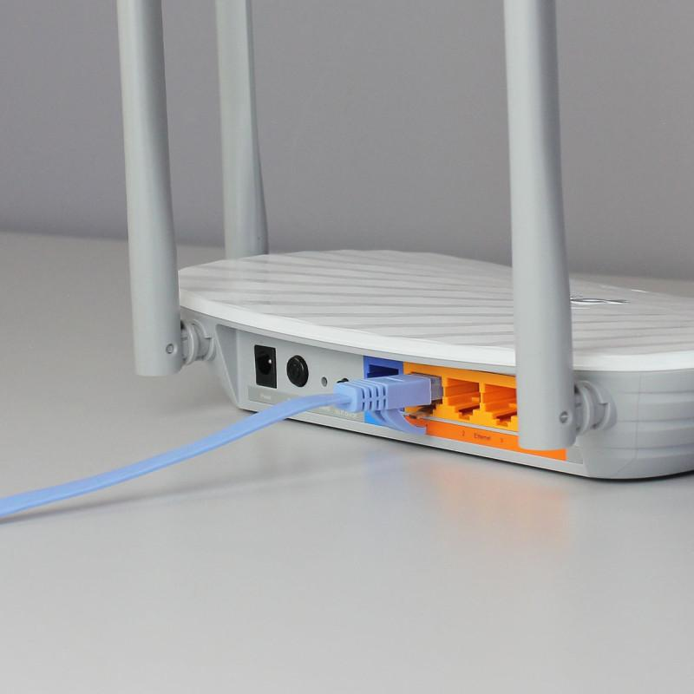
The cable shown is a Cat6 Ethernet cable with an RJ-45
connector. It can connect a Wi-Fi router to a laptop, desktop
computer, network switch, or other Ethernet-enabled device.
It provides a wired network connection for transmitting data.

